Eventi
Use Case Specification

Submitted to:

Asst. Prof. Ma. Rowena C. Solamo
Faculty Member
Department of Computer Science
College of Engineering
University of the Philippines, Diliman

Submitted by:
Dimaano, Aaron Diego I.
Lopez, Matthew S.
Torres, Jacob Angelo V.

In partial fulfillment of academic requirements
for the course
CS 191 Software Engineering I
of the
1st Semester, AY 2015-2016
Unique Reference:
The documents are stored in https://github.com/Tom-2013-06417/CS191-192_Event_Sharing/tree/master/02-Requirements%20Engineering.
Link to this document: https://github.com/Tom-2013-06417/CS191-192_Event_Sharing/blob/master/02-Requirements%20Engineering/2.0%20-%20Search.pdf.

Document Purpose:
The purpose of this document is to exhaust the step-by-step process of the Use Cases in every scenario possible.

Target Audience:
To our project client and adviser, our fellow 191 classmates, and our future selves when they need to refer back to this document.

Revision Control:

Revision Date | Person Responsible | Version  Number | Modification
09/18/15 | Dimaano, Diego | 0.1 | Initial Draft of Flow of Events
09/18/15 | Lopez, Matthew | 1.0 | Initial Document
09/25/15 | Torres, Jacob | 1.1 | Edited the post-conditions

Use-Case Name: Search

Description: The Eventi system’s main feature is search. The search function would be acted by both Guest and Registered Users. The function would include tags and filters as to limit search queries and display the most relevant answers.

Preconditions: The user has already loaded the Eventi home page.

Flow of Events:

Scenario Name | Description
Scenario 1 (Basic Flow)  User searches for an event/organization's profile | - User uses the search query functionality
Scenario 2  User found the event they were looking for | - User sees the search query results  - User terminates the query
Scenario 3  User did not find the event they were looking for | - User sees the search query results  - User terminates the query

Activity Diagram of the Flow of Events:

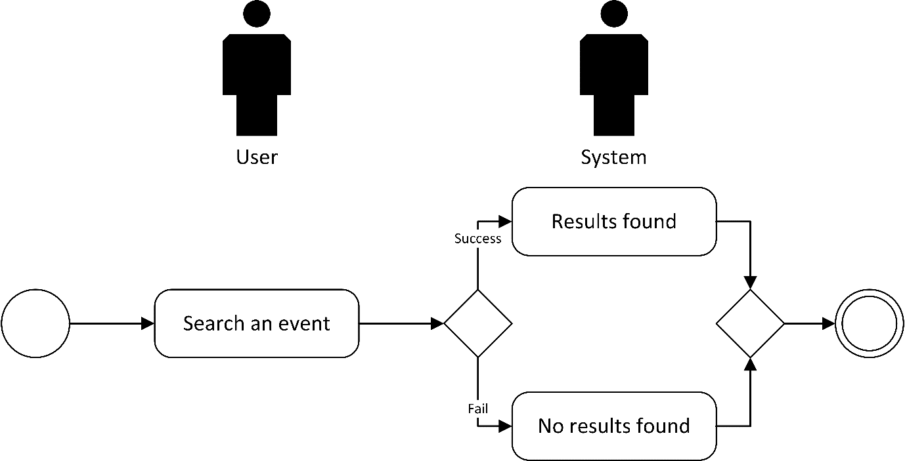

Post-conditions: NONE

Special Requirements: NONE

